

**Government of Andhra Pradesh**

**Revenue Department**

**User Manual**

**For Applying**

**Mutation for Corrections**

The Applications filed by the Digital Assistant at GSWS center will be received in the following categories from GSWS Portal for further Process of Webland.

|  |  |
| --- | --- |
| Existing Mutation Services | Proposed Mutation Services |
| 1. Mutation and Title Deed cum PPB | 1. Mutation and Title Deed cum Pattadar Passbook |
| 1. Mutations |
| 1. Rectification of Entries in Record of Rights |

**Scenarios:**

**a) Mutation for Corrections**

**b) Mutation for Transactions**

**c) Mutation for Transactions with Corrections**

**Step-1:**

Digital Assistant shall choose the Service “**Mutation and Title Deed cum Pattadar Passbook**”

**Step-2:**

Applicant details will be prefilled based on the Aadhaar Number from House Hold Database.

**Applicant Father's Name** detail need to enter manually.

**Relation with Pattadar** need to be selected manually and it is mandatory column.

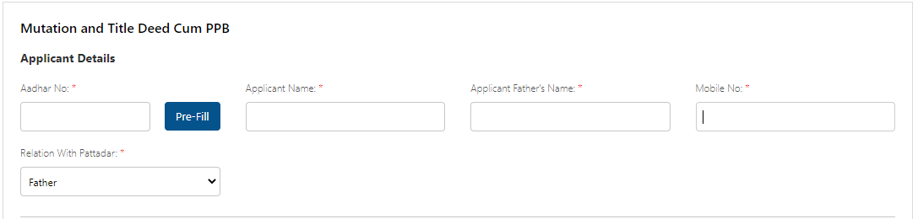

**Step-3:**

Pattadar Authentication shall be done based on Biometric / OTP.

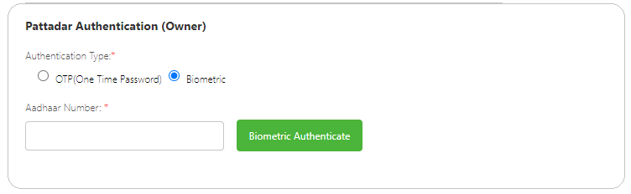

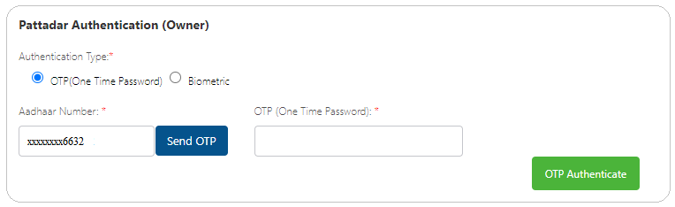

Pattadar Details will be displayed based on the Aadhaar Number given at “**Pattadar Authentication**”

**Step-4:**

Pattadar Details (Basic Details, Permanent Address and Mailing Address) will be prefilled based on the Aadhaar Number given at “**Pattadar Authentication**”

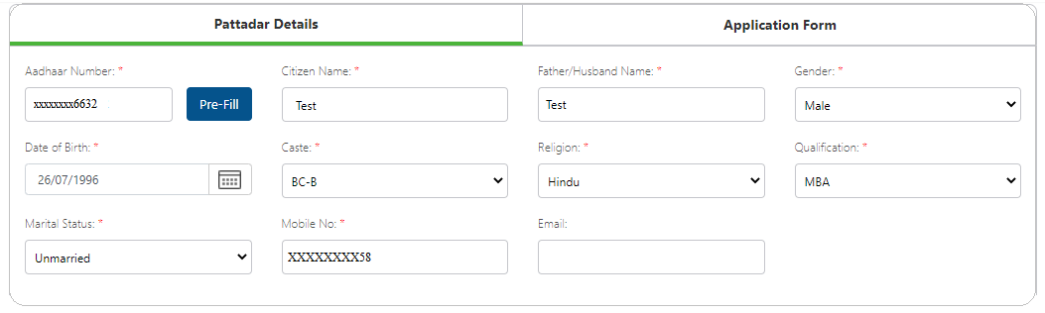

Permanent Address will auto populate based on the Aadhaar from the House Hold Database.

**Note: Postal Office and Postal Village details will be displayed based on Pincode and need to be selected based on the Postal Office located near to Applicant Address.**

If

Present Address (Mailing Address) is same as Permanent Address then click on “ **Present Address is same as Permanent Address**”

Else

Enter Address Manually and click on “**Continue**” Button

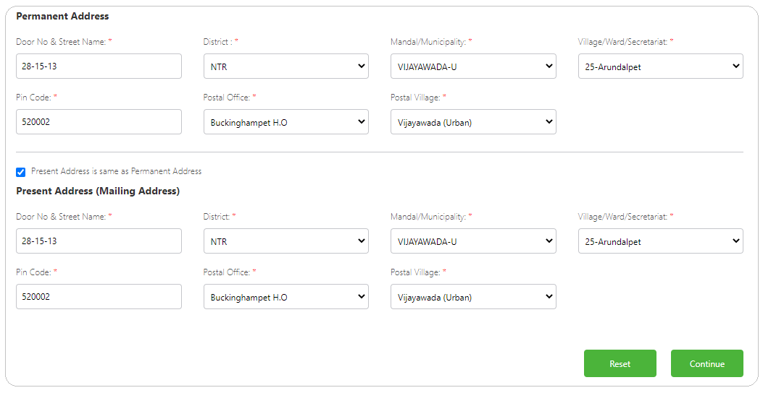

**Step-5:**

Land Details “District, Mandal, Village” shall be entered Division will be auto-displayed based on Village. Aadhar number will pre-populate.

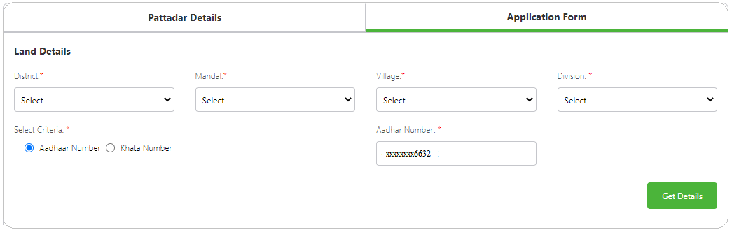

Click on “**Get Details**” button

**Step-6:**

ROR/Adangal Details shall be displayed as mentioned below.

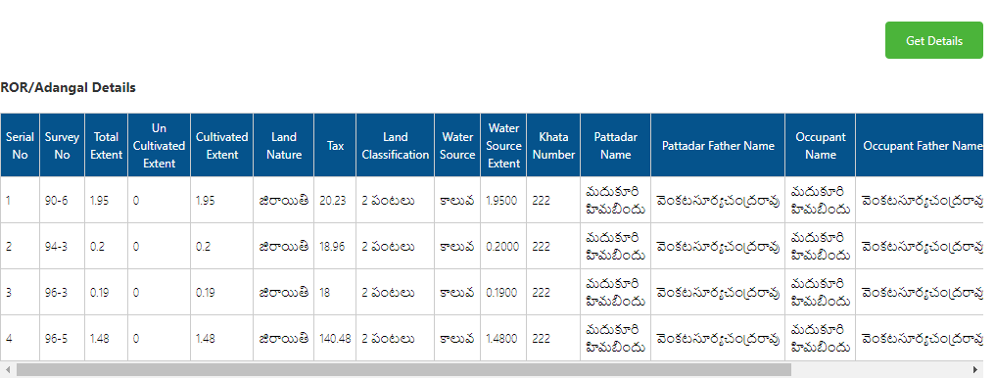

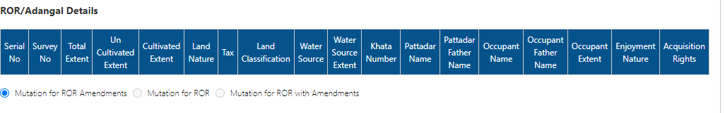

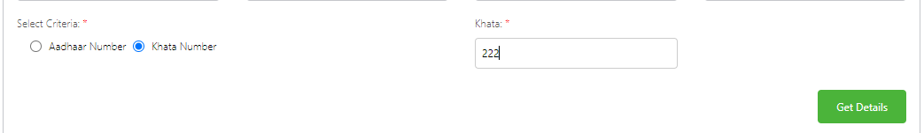

**Step-7:**

Select Survey Number for which the correction is to be done under “**Edit Adangal Details**” section.

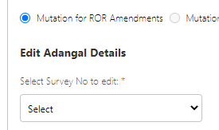

**Step-8:**

Edit the required ROR/Adangal Columns and click on “**Apply**” Button.

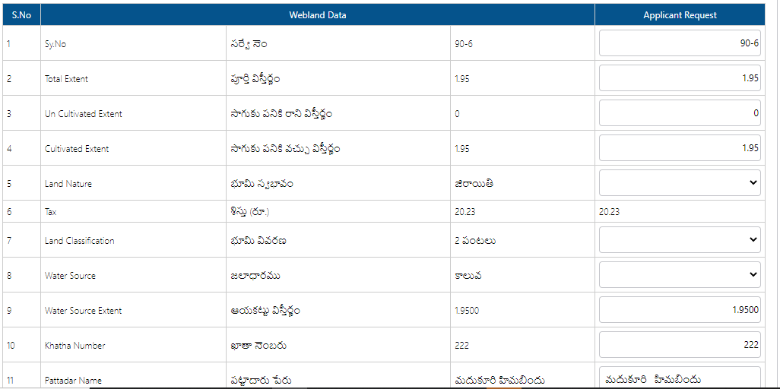



**Step-9:**

Select the Passbook Type “**e-Passbook** or **Security Printed Pattadar Passbook**” based on the user requirement.

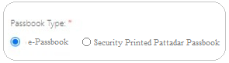

**Step-10:**

Upload the required Documents mentioned below and click on “**Show Payment**” Button.

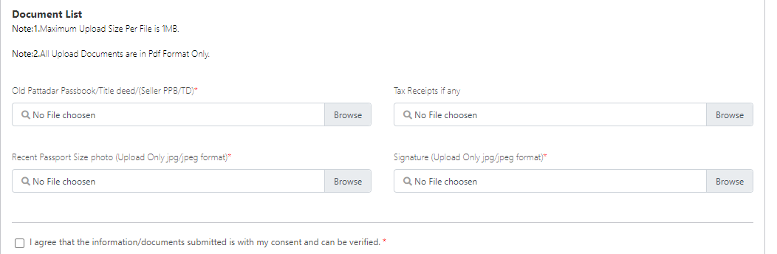

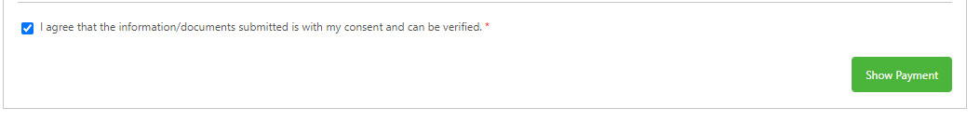

**Step-11:**

After Successful Payment the request shall be posted to Webland Tahsildar Login for further Processing.